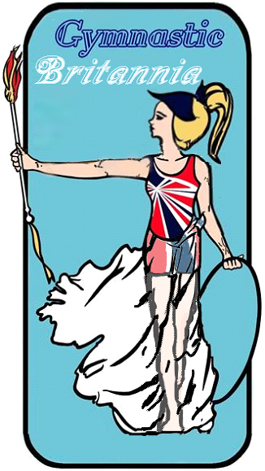
JOIN BEFORE 5TH SEPT 2021 TO HAVE FIRST YEAR’S CLUB MEMBERSHIP FREE!!
I am pleased to announce that in October a new Organisation is launching, specifically designed for Recreational Clubs, Coaches and Participants.
Here are some of our offerings:
Clubs & Officers / Directors
- Online Portal to for registering / Paying that you can link with your club admin system*
- £10 Million Public & Products Liability
- £10 Million Professional Indemnity
- £2 Million Directors’ & Officers’ Liability
- £10 Million Employers’ Liability
- 1 Month Subscription for Gymnastics Music
- Access to Virtual Competitions with 5% discount
- Customer service access Mon-Fri including Saturdays 1-4pm (Excluding Bank Holidays and Holiday Periods)
- Online Members Magazine 3 editions a year!
Jan, May, Sept (Receive 1 CPD point for each edition you read)
- Members Newsletter 12 editions a year Jan-Dec (Receive 1 CPD point for each edition you read)
- Dual Membership Scheme ability, yearly membership combined with day memberships for those who are in PAYG Sessions.
- Ability to have your staff Enhanced DBS Checked.
- Exclusive Access to Grow your Own Coaches scheme™ (once launched)
- Opportunity for all coaches to earn continual professional development (CPD) Points from Courses, plus so much more. With the required 12 points a year to reregister can be achieved simply just from reading our newsletter monthly, plus so much more.
- Ability for clubs to run sanctioned competitions
- Access to Child Protection Training
- 10% off Gym Quest (Quality Assurance accreditation for clubs)

Coaches:
- £10 Million Public & Products Liability
- £10 Million Professional Indemnity
- 12months UKCoaching Subscription Membership
- Access to Child Protection Training
- Free Courses / reduced price courses**
- Recreational Coaching Pathways Trampolining and Gymnastics (other pathways will be added.)
- 1 Month Subscription for Gymnastics Music
- Access to Virtual Competitions with 5% off
- Customer service access Mon-Fri including Saturdays 1-4pm (Excluding Bank Holidays and Holiday Periods)
- Online Members Magazine 3 editions a year
Jan, May, Sept.
- Members Newsletter 12 editions a year Jan-Dec
- CPD Opportunity.
Participants:
- £10 Million Public & Products Liability
- Customer service access Mon-Fri including Saturdays 1-4pm (Excluding Bank Holidays and Holiday Periods)
- 2 free credits for Gymnastics Music
- Online Members Magazine 3 editions a year
Jan, May, Sept.
- Members Newsletter 12 editions a year
Jan-Dec
- 50% discount on some virtual lessons.

Membership Rates:
Membership Fees: Yearly 1 Oct 21 - 31 Sept 22
Club Affiliation 50.00 (Or free if you register before 5th Sept)
(1st Year of club registration free if club registers before 05 September 2021)
Pre-school Membership 11.50
Gymnast Membership 4yrs + 14.99
Coach Membership 55.50
Qualified Assessor / Assistant Coach 35.00
Directors / Officers Membership 14.99
Day membership^ PAYG Fees: Specially for PAYG Club Sessions
^(Day Membership only covers performers not coaches)
PAYG Day Membership U18yrs 0.50 per member per session (Payable end
of each month)
PAYG Day Memberships O18yrs 1.00 per member per session (Payable end
of each month)
Alternatively if you have set places you are able to register a specific amount of spaces for the year for example
If you have 2 sessions that have a total of 25 participants per year you are able to do a set fee per space.
Pre-school U4yrs 12.99
Cost for U18yrs 16.99
Cost for O18yrs 18.99

*Online linking is subject to using the same service for your club.
** These courses via the UKCoaching Subscription.

